ASSINIBOINE PARK HOCKEY ASSOCIATION (APHA)
DIRECT DEPOSIT
AUTHORIZATION FORM

Please complete this form to authorize Direct Deposits of fees for Officials
(Referee and Timekeeper)

Please check one of the following:  ☐ New application for direct deposit | ☐ Change of information |  | ☐Cancellation

Identification
Name: Click or tap here to enter text.
Address: Click or tap here to enter text.
City: Click or tap here to enter text. Province: Click or tap here to enter text.
Postal Code: Click or tap here to enter text.
Telephone #: Click or tap here to enter text.
Email Address: Click or tap here to enter text.

Bank Account Information
Please check one of the following:
☐I am the owner of the bank account specified below.
☐I am not the owner of the bank account specified below, but authorize the amounts owing to be deposited to
this account.

Name on bank account, if different from above: Click or tap here to enter text.
Attach a blank cheque with the banking information encoded on the cheque and write “VOID” across the front
(RECOMMENDED) OR complete the banking information area below (see example on page 3):

Branch Number Institution Number Account Number
(5 digits) (3 digits) (up to 12 digits)

Certification

I, as the person entitled to receive the payments of the Officials Fees, authorize Assiniboine Park Hockey Association (APHA) to deposit the payments into the above noted bank account until further notice.

Signature: Click or tap here to enter text. | Date: Click or tap here to enter text.

PLEASE RETURN TO TED SZYPOWSKI, TREASURER, APHA
Email: zts49@mymts.net

APHA – DIRECT DEPOSIT

Additional Information

CONVENIENCE
The Pre-authorized deposit method eliminates the possibility of lost or stolen cheques. Deposits are made directly to your bank or financial institution account.

DEPOSIT DATE
Referee / Timekeeper deposits will be made on a monthly basis. Your deposit will be confirmed by e-mail.

PROOF OF DEPOSIT
Your deposits are recorded automatically and individually on your monthly bank statement or passbook.

STATEMENT
Your statement contains information outlining your games worked and applicable amounts. It will be forwarded to your e-mail address by the Referee Assignor.

CHANGE OF ADDRESS or FINANCIAL INSTITUTION
Please submit an updated form with the new information if you change your address or your bank account.

PROTECTING YOUR PERSONAL INFORMATION
APHA recognizes and respects every individual’s right to privacy. APHA will take steps to protect any personal information that is provided.

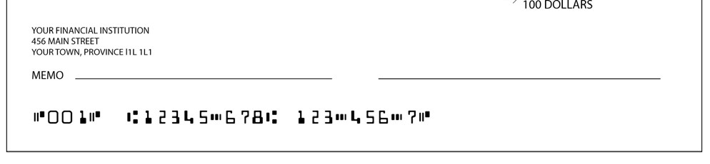
Bank information from your passbook, account statement, cheque, or financial institution

This is the bank account number used for direct deposit

This is the financial institution number (3 digits)
.

This is the branch number (5 digits)

This is the cheque number (do not enter this number)

